
Subject Theme Overview Year 6 Charlton Kings Junior School

Subject | History | Theme | A study of a theme which extends chronological knowledge: Crime & Punishment | Term | 1 - 2
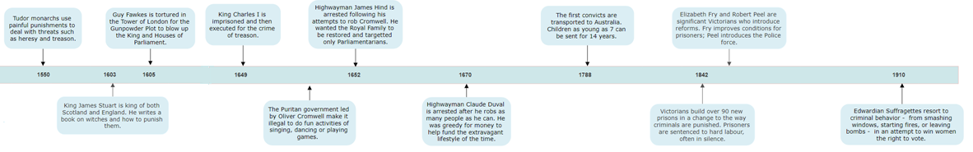

What should I already know? |  | What knowledge should I know by the end of the unit? |  | What historical enquiry and knowledge of historians’ work will I have done by the end of the unit? |  | Vocabulary
SOCIETY  There have been changes to religious beliefs before: the early Anglo-Saxons worshipped many gods before converting to Christianity. Women had been subordinate to men in society for a long time, as seen by the Roman and Norman laws imposed on women. This extends prior learning about Ancient Athens where democracy was first introduced but was denied to women in society.  TECHNOLOGY  Technology has a significance in how crimes can be committed: longships were unique in enabling long voyages but also passage into shallow waters which enabled the Vikings to commit coastal raids and steal treasures from monasteries as a planned target of known wealth.  SETTLEMENT  The Romans, and later the Normans, had settled in Britain and imposed laws on the existing populations. In both cases, their settlements resulted in changes to Britain by introducing ideas and customs they each brought from Rome and Normandy. |  | “Were painful punishments the only way to control society?”  In this second half of a study of crime and punishment, I will learn of many changes in society from the Tudors to the Suffragettes. I will see how crime was used to try to bring about change by some groups. In turn, I will learn of changing punishments designed to control and deter the threats posed by these people.  I will see how changes to religion were a cause for some criminal actions, including the significance of the Gunpowder Plot as an infamous crime remembered to this day. I will learn how changes in technology enabled criminals to enact new ways of committing crimes, such as highwaymen, and the development of printed leaflets in sharing their antics with the public. Major technological changes seen in the Industrial Revolution contributed to a new form of punishment as convicts could be transported to Australia for petty theft. Reforms to punishments came with Victorian prisons yet Suffragettes continued to use crime to fight for changes they sought in society. |  | I will complete historical enquiries about:  Sources & Evidence – What do primary sources tell historians about attitudes to the Suffragettes?  Interpretation – Why do historians have different ideas about who was to blame for the Gunpowder Plot?  Similarities & Differences – How can historians use the examples of Captain James Hind and Claude DuVal to understand the similarities and differences between highwaymen?  Cause and Consequence –How did Henry VIII’s new religion lead to painful punishments? Why do some historians think that the punishment of transportation was an opportunity for thieves in Britain?  Significance – Why do we remember the Gunpowder Plot?  Change – How much did life change for people when King Charles I was beheaded for treason? What does a visit to Oxford Castle and Prison reveal about Victorian reforms to punishments?  I will develop chronological awareness by recalling the chronological order of eras in British History from the Tudors to Edwardians. |  | Conspirators | A group of people who plot and plan a crime of significance.
 |  |  |  |  |  | Convict | A person found guilty of a criminal offence who is serving a sentence.
 |  |  |  |  |  | Heretic | A person who commits the crime of heresy – going against the established religion of the country.
 |  |  |  |  |  | Highwayman | An opportunistic criminal who held up passing travellers on roads to steal their possessions.
 |  |  |  |  |  | Industrial Revolution | A change to use steam powered technology to make goods in huge quantities which could be traded all over the world; Britain colonised Australia and sent it convicts there.
 |  |  |  |  |  | Puritan | An English Protestant who followed strict and simple forms of worship. Many ‘fun’ activities became illegal under the Puritans.
 |  |  |  |  |  | Suffragette | A woman who believed in ‘Deeds, Not Words’ to campaign for women’s rights to have the vote.
 |  |  |  |  |  | Torture | Inflicting pain on someone with the aim of getting a confession.
 |  |  |  |  |  | Treason | A serious crime of plotting against the country or monarch.

