
Subject Theme Overview Year 6 Charlton Kings Junior School

Subject | History | Theme | A study of a theme which extends chronological knowledge: Crime & Punishment | Term | 1

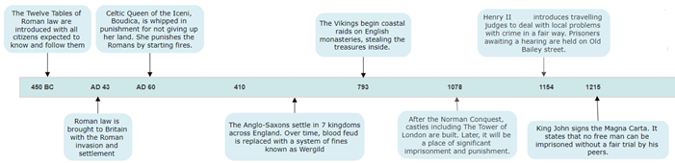

What should I already know? |  | What knowledge should I know by the end of the unit? |  | What historical enquiry and knowledge of historians’ work will I have done by the end of the unit? |  | Vocabulary
CIVILISATION  The earliest civilisations occurred outside of Europe. In Ancient Egypt, pyramids were built with intricate traps to deter thieves and criminals from the treasures within. The first civilisation in Europe was in Ancient Greece. Draco introduced a system of law to replace Blood Feud in Ancient Greece although his punishments were harsh. The Romans were influenced by the Ancient Greek civilisation.  INVASION  The Iron Age Celts lived in hillfort settlements to protect their tribes from local invasions. They resisted Caesar in his first invasion attempt but the Romans eventually succeeded and Romanised Britain. The Vikings did coastal raids to steal treasures from Christian monasteries before invading.  POWER  The Anglo-Saxons settled in 7 kingdoms and the borders of these changed as the influence and power of different kings extended over new territories. Alfred the Great was named for his strategy of Danelaw – an agreement made with the Vikings. Athelstan was the first King of England. |  | “Where does our law and order come from?”  In this first half of a study of crime and punishment, I will understand the historical grounding for the British system of law and order as a feature of our modern civilisation. I will first learn of the Roman civilisation and the methods of punishment used to control the invaded populations of its empire. I will see this as a contrast to the legal systems in place for its own citizens and the significance of Boudica’s rebellion after she received such punishment. I will discover the lasting legacy of Anglo-Saxon society in establishing shire communities to deal with crime locally and the responsibilities of individuals to both prevent crime and serve justice. In learning of the Norman Conquest over Anglo-Saxon England, I will understand the position and authority of the monarch and the structures in place to enforce the power of the King. I will learn how we get our judges today from King Henry II and the legacy and significance of the Magna Carta on our lives today. |  | I will complete historical enquiries about:  Sources & Evidence – What do the Twelve Tables tell historians about law and order in the Ancient Roman Civilisation?  Similarities & Differences – How can historians use the example of Boudica to find similarities and differences in punishments for Roman and  non-Roman citizens in Britain?  Cause – How did having one king of England cause a new system of law and order in Anglo-Saxon England?  Change – How much did the Norman victory at the Battle of Hastings change law and punishments for the Anglo-Saxons?  Significance – Why do historians throughout time have different interpretations about the significance of King John signing the Magna Carta?  I will develop chronological awareness by securing and extending prior learning from prehistory to the later Middle Ages and use the Roman punishment of crucifixion as a marker for the transition from BC to AD. I will construct accounts of history using informed responses based on facts. |  | Corporal Punishment | The use of physical force or violence as a punishment.
 |  |  |  |  |  | Capital Punishment | A punishment so severe that the convicted person lost his or her life.
 |  |  |  |  |  | Blood Feud | ‘Fighting to the death’. The early Anglo-Saxons would settle disputes by taking revenge violently.
 |  |  |  |  |  | Wergild | A system of fines agreed in law as a punishment for harming someone.
 |  |  |  |  |  | Mutilation | A severe punishment where the criminal would have part of their body cut or removed completely.
 |  |  |  |  |  | Trial by Ordeal | A belief that God could decide someone’s guilt or innocence after the accused had been made to perform a difficult or painful task.
 |  |  |  |  |  | Murdrum | A huge fine given to an entire Anglo-Saxon village if a Norman was found murdered by them.
 |  |  |  |  |  | Magna Carta | Latin for ‘Great Charter’. It granted free people the right to fair trial and some parts are still law today.
 |  |  |  |  |  | Civilisation | An advanced society with law, order, culture and developed technology including writing.

